- The main takeaway from November's UK GDP release is that the monthly series is very noisy and should be handled with care. The bigger picture is that the economy has flatlined since early-2022. But 2024 should be the year that breaks that pattern, with a sharp fall in inflation set to boost household spending power and generate a steady pickup in momentum.
- Mortgage rates have fallen sharply as markets anticipate that lower inflation will mean a more aggressive path for rate cuts. Lower mortgage rates will limit the rise in debt servicing costs for those refinancing this year and further reduce the risk of a sharp fall in house prices. But most of the boost to GDP growth from looser monetary policy will emerge in 2025 and beyond.
When last month's GDP release reported a surprisingly large 0.3% m/m fall in GDP in October, we had cautioned against reading too much into that decline because the official output series is very noisy and regularly offers false signals. That guidance proved accurate, with GDP having rebounded by 0.3% in November. Most of the sectors that saw output fall in October enjoyed a rebound the following month (Chart 1).
That guidance also applies to quarterly data. Where December's outturn lands is very uncertain given the offsetting influences of stronger business survey results and further industrial action in the public sector. So on a q/q basis, GDP could either have grown slightly or contracted a little in Q4. But ultimately whether we get a small rise, or a small fall (that would represent a second successive quarterly decline), is a piece of trivia rather than anything meaningful, particularly given that subsequent revisions might paint an entirely different picture of this period in the future. However, that's unlikely to stop some commentators obsessing about whether the criteria for the arbitrary definition of a so-called 'technical recession' have been met.
The bigger picture is that output has essentially flatlined since the boost from the post-pandemic reopening faded in early-2022. But we are optimistic that the economy will be able to break out of that pattern in 2024, with momentum set to build as we move through the year.
Chart 1: GDP has continued to oscillate around a flat trend
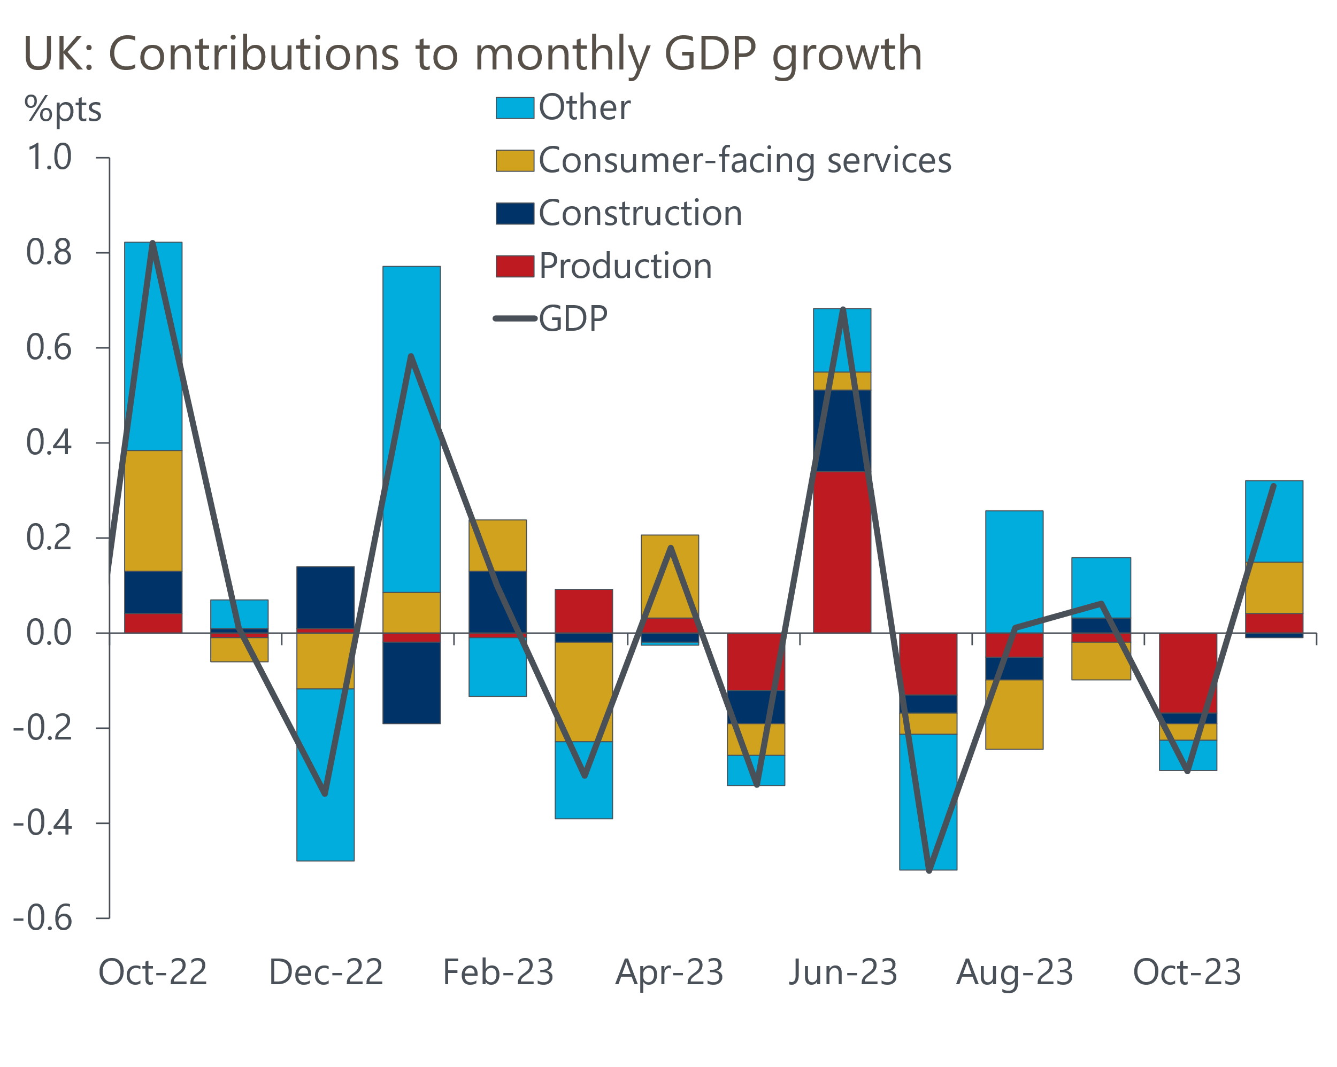
Source: Haver Analytics

The main reason for our optimism is the transformation in the inflation outlook over the past few months. As our recent note argued, the combination of lower oil and wholesale gas prices, along with softer core price pressures, should generate a much quicker fall in inflation than we previously anticipated. Indeed, we now think that inflation will return to the Bank of England's 2% target as soon as April.
If we're right, it would mean that inflation comes in 2ppts below the BoE's latest forecast in Q2. Against this backdrop, we expect the Monetary Policy Committee to steadily back down from their hawkish rhetoric. We expect the first cut in Bank Rate to come in May, with three further 25bps cuts following before the end of the year.
Financial markets have taken a similar view on the turnaround in the inflation outlook, and the change in sentiment is increasingly being reflected in interest rates paid by households and firms. The BoE's quoted interest rate data reported that average two- and five-year fixed rate deals for 75% loan-to-value mortgages fell by 25bps and 20bps respectively between November and December. This took their total falls to 119bps and 103bps compared with their July peak (Chart 2)
Chart 2: Mortgage rates have continued to fall in response to declining swap rates
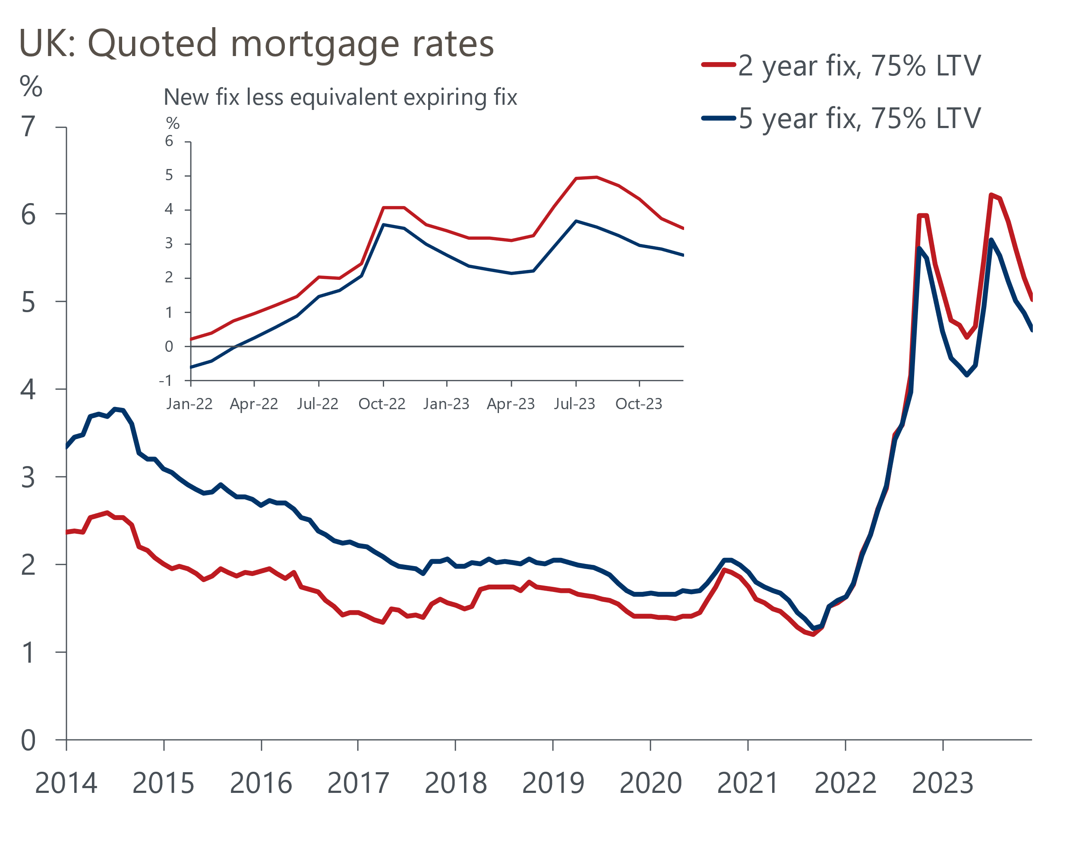
Source: Haver Analytics
Several lenders have announced new, cheaper, deals over the past couple of weeks, so the January data should show a further drop in quoted rates. But recent movements in financial market pricing suggests that mortgage rates might not go any lower in the near-term – two- and five-year swap rates have risen by 22bps and 27bps respectively since the end of December, as markets have pared back their expectations for rate cuts and brought pricing broadly into line with our forecast.
But notwithstanding the recent rebound in swap rates, the prognosis for the housing market looks far less gloomy than it was a few months ago. The combination of lower mortgage rates and strong nominal earnings growth has meant that valuations look much less stretched than before. And while the 1.5mn mortgagors refinancing this year face a substantial increase in their debt servicing costs, that uplift will now be much smaller than appeared likely a few months ago. This should mean fewer borrowers get into financial stress, limiting the number of forced sales. Historically, house price corrections have tended to average 16% in nominal terms, with the smallest in our sample being 9% in the early-1990s. We think there's a good chance that the current cycle will see prices fall only half as much as they did in the 1990s.
With regard to the wider economy, we expect the boost from looser monetary policy will be seen more in 2025 than this year, with the firmer outlook for 2024 mostly due to lower inflation. At first glance, the upgrade to our near-term GDP forecast looks modest – our new projection shows calendar year GDP growth of 0.6% in 2024, up just 0.1ppt on last month. But just as m/m growth rates can be misleading, calendar year growth rates don't always tell the full story either! Though we have raised our forecasts for q/q GDP growth in each quarter of 2024, the carry-over effect from incorporating the downward revisions to the recent history in the latest national accounts has dampened the growth rate for this year.

The week ahead
Tuesday's labour market release is due to see the Labour Force Survey series reintroduced, the first new data since the September publication. The new series will incorporate improved adjustments for non-responses and use updated population estimates. The data should also be based on a larger sample, following ONS attempts to improve response rates. But we must wait another couple of months for the new Transformed Labour Force Survey to become fully operational. The gap between releases means it's hard to predict what the data will say about unemployment, but our best guess is that the jobless rate for the three months to November will be around 4.3%.
The momentum behind pay growth has been much softer of late, with the level of average total pay reported to have fallen between September and October. There's a good chance this drop will be revised away, given revisions tend to have an upward bias. But even so, we expect to see a further cooling in headline (three-month average of the annual rate) pay growth in November. We expect total pay growth to drop to 6.9%, with the regular pay measure cooling to 6.7%.
Inflation has consistently undershot expectations in recent months, with softening core inflation the key factor. We think some of November's weakness might relate to the data being collected later than in 2022, meaning it captured more Black Friday discounting, so this factor should unwind in December. Though weekly data on pump prices shows a 5% fall in petrol prices between November and December, there was a similar fall in the previous year so this shouldn’t have increased the downward pressure on inflation. But strong base effects will keep food price inflation on a downward path and should mean that CPI inflation slows to 3.8%, from 3.9% in November.
Retail sales rebounded in November, after weak outturns in September and October. December's retail surveys from the CBI and BRC were underwhelming, and sales in food stores were unusually high in November so there could be some payback in December. We pencil in a 0.1% m/m fall in sales, with risks skewed towards a worse outcome.
Table 1: Week ahead calendar
Date | Events | Period | Measure | Unit | Previous | Forecast
Jan 16 | ILO unemployment | Sep-Nov | Rate | % | N/A | 4.3
Jan 16 | Average earnings (total pay) | Nov | 3m, y/y | % | 7.2 | 6.9
Jan 16 | Average earnings (regular pay) | Nov | 3m, y/y | % | 7.3 | 6.7
Jan 17 | CPI inflation | Dec | m/m | % | -0.2 | 0.2
Jan 17 | CPI inflation | Dec | y/y | % | 3.9 | 3.8
Jan 17 | RPI inflation | Dec | m/m | % | -0.1 | 0.6
Jan 17 | RPI inflation | Dec | y/y | % | 5.3 | 5.3
Jan 17 | Producer input prices | Dec | m/m | % | -0.3 | -1.0
Jan 17 | Producer input prices | Dec | y/y | % | -2.6 | -2.4
Jan 17 | Producer output prices | Dec | m/m | % | -0.1 | -0.5
Jan 17 | Producer output prices | Dec | y/y | % | -0.2 | 0.1
Jan 17 | Land Registry house prices | Nov | y/y | % | -1.2 | -1.7
Jan 19 | Retail sales inc fuel | Dec | m/m | % | 1.3 | -0.1
Jan 19 | Retail sales inc fuel | Dec | y/y | % | 0.1 | 1.5
Source: Oxford Economics

Key forecasts
Table 2: UK forecast overview
(Annual percentage changes unless specified)
 | 2021 | 2022 | 2023 | 2024 | 2025 | 2026
GDP | 8.7 | 4.3 | 0.3 | 0.6 | 1.6 | 1.9
Private consumption | 7.5 | 4.8 | 0.5 | 0.9 | 1.8 | 1.9
Fixed investment | 7.4 | 8.0 | 2.3 | -3.2 | 0.5 | 2.8
Government consumption | 14.9 | 2.3 | 0.6 | 4.3 | 2.1 | 1.6
Exports of goods and services | 4.9 | 9.0 | -0.5 | 0.4 | 2.8 | 2.4
Imports of goods and services | 6.1 | 14.6 | -1.1 | 2.5 | 2.9 | 2.7
Industrial Production | -3.9 | -3.5 | -0.3 | -0.1 | 0.9 | 1.5
Consumer prices | 2.6 | 9.1 | 7.3 | 2.1 | 1.6 | 1.8
Unemployment rate (%) | 4.5 | 3.7 | 4.1 | 4.5 | 4.3 | 4.0
Current a/c balance (% of GDP) | -0.5 | -3.1 | -2.8 | -2.7 | -2.7 | -2.7
Government balance (% of GDP) | 7.2 | 4.4 | 5.4 | 3.3 | 2.9 | 2.4
Cen. bank policy rate (%, EOP) | 0.25 | 3.50 | 5.25 | 4.25 | 3.25 | 2.25
10yr govt. bond yield (%, EOP) | 0.97 | 3.67 | 3.54 | 3.59 | 3.37 | 2.92
Exchange rate (US$ per £, EOP) | 1.35 | 1.20 | 1.27 | 1.26 | 1.28 | 1.31
Exchange rate (euro per £, EOP) | 1.19 | 1.13 | 1.15 | 1.16 | 1.15 | 1.15
Source: Oxford Economics
Table 3: Quarterly forecasts for the UK
 | 2023 |  |  |  | 2024
 | Q1 | Q2 | Q3 | Q4 | Q1 | Q2 | Q3 | Q4
GDP (% year) | 0.4 | 0.3 | 0.3 | 0.2 | 0.2 | 0.4 | 0.7 | 0.9
CPI inflation (% year) | 10.2 | 8.4 | 6.7 | 4.1 | 3.7 | 1.6 | 1.7 | 1.6
Bank Rate (%, EOP) | 4.25 | 5.00 | 5.25 | 5.25 | 5.25 | 4.75 | 4.50 | 4.25
10yr gilt yield (%, EOP) | 3.47 | 4.39 | 4.46 | 3.54 | 3.75 | 3.64 | 3.61 | 3.59
US$ per £ (EOP) | 1.24 | 1.27 | 1.22 | 1.27 | 1.25 | 1.25 | 1.25 | 1.26
Euro per £ (EOP) | 1.14 | 1.17 | 1.15 | 1.15 | 1.16 | 1.16 | 1.16 | 1.16
Source: Oxford Economics

Latest Country Economic Forecast:
December 11, 2023

Recent publications

Data Insights
The economy returned to growth in November
Services PMI suggests the sector ended 2023 on a high
More signs of life in the housing market
Manufacturing sector ended 2023 on a weak footing
National accounts paint a weaker picture for 2023

Research Briefings
The boost from falling rates will be a slow-burner
Three reasons why inflation will swiftly return to target
Rethinking QE in light of large asset purchase losses
Nowcast suggests wage momentum continues to cool
BoE continues to push back on hopes of near-term rate cuts

Contacts

Oxford Economics' UK team
- Andrew Goodwin - Chief UK Economist - agoodwin@oxfordeconomics.com
- Edward Allenby - UK Economist - eallenby@oxfordeconomics.com

